[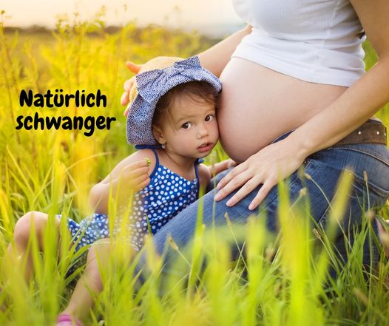](https://www.facebook.com/groups/natuerlich.schwanger/?__cft__%5b0%5d=AZXUq-Abx3Cc4LB1n1HFIF1PrxqAnW27AkDJcECBZ3i2BKG22372Qytnhox7s_CsmTfjiPr0KZVN5gVP9kuHA66GVmRUq98n5WFegQQYPJCvFiBgmXiqHM-qCFopcjZr_9B9_44yQeW-lH2gIC-VFXuU&__tn__=H-R)